12/7/2024 Exception Handling

Ques>What are the advantages and disadvantages of using exceptions in C++ compared to traditional error codes?

### **Advantages of Exceptions:**

1. **Easier Code Flow**: Exceptions help keep the main program logic clean by separating normal operations from error handling. This makes it easier to follow how the program works.
2. **Automatic Error Handling**: When an exception is thrown, C++ automatically checks if there's a piece of code (a "catch block") to handle it. This saves you from writing lots of repetitive error-checking code.
3. **Detailed Error Messages**: Exceptions can carry specific information about what went wrong, like error messages or types, which can be really helpful when trying to figure out and fix problems in your program.

### **Disadvantages of Exceptions:**

1. **Performance Hit**: Exceptions can slow down your program because they involve extra behind-the-scenes work to manage and process. This might not be a big deal for most programs, but it can matter for things that need to be really fast.
2. **Complexity**: Exception handling can make your code more complicated, especially if you have lots of different kinds of exceptions or if exceptions can happen in many places. This can make it harder to understand and maintain your code.
3. **Compatibility Issues**: Exception handling might work differently depending on which compiler or computer system you're using. This can sometimes cause problems when trying to move or share your code.

Q.2>How can you ensure that exception classes provide informative error messages for debugging?

Sure, let's simplify it:

When you create custom error messages for exceptions in C++, you want them to be clear and helpful so that when something goes wrong in your program, you can easily figure out what caused the problem. Here’s how you can ensure your error messages are informative:

1. **Use Clear Messages**: Make sure the error message explains what went wrong in simple terms. For example, instead of just saying "Error!", you could say "Failed to open the file 'data.txt'."
2. **Give Specific Details**: Include details that can help you understand where the problem occurred. For instance, mention the file name, function name, or any important numbers related to the error.
3. **Create Different Types**: Make different types of errors for different situations. Each type of error can have its own message that explains why it happened.
4. **Follow Naming Rules**: Use standard names for your error messages and the parts of your code that deal with errors. This makes it easier for others to understand and use your code.
5. **Throw Errors Carefully**: When you find a problem in your program, make sure to throw an error that includes a helpful message. This helps the person who is trying to fix the problem understand what happened.

By doing these things, you can make sure that your error messages are useful. This makes it easier to fix problems in your program and to understand what went wrong.

Q.3>Discuss strategies for optimizing exception handling performance, especially in performance-critical applications.

1. **Use Exceptions Wisely**: Only use exceptions for real problems that are unusual. Don't use them for things that happen normally.
2. **Avoid Using Exceptions in Loops**: If you have a loop that runs many times, try not to use exceptions inside it because they can slow things down a lot.
3. **Be Efficient When Throwing Exceptions**: When you throw an exception, try to do it in a way that doesn't take too much time. Don't make complex exceptions unless you really need to.
4. **Catch Specific Problems**: When you handle exceptions, try to catch specific types of problems instead of catching all possible problems. This can make handling them faster.
5. **Check Performance with Tools**: Use tools that can check how fast your program runs and find places where exceptions are causing problems. This way, you can fix those spots.
6. **Use Simple Error Checks**: Sometimes, instead of using exceptions, you can use simpler ways to check if something went wrong, like using numbers or flags to show errors.
7. **Let Your Code Help**: Write your code in a way that helps avoid needing exceptions too much. This can make your program faster and easier to understand.

By following these tips, you can make sure that your program runs faster even when you're using exceptions to handle problems. This is important for programs that need to work quickly and efficiently.

Q.4 How can you design a hierarchy of exception classes for improved code maintainability and reusability?

### **Steps to Design Exception Class Hierarchy:**

1. **Identify Common Base Class**:
   * Start by defining a common base class for all your custom exceptions. This base class should inherit from std::exception or its appropriate derivative to integrate well with standard C++ exception handling mechanisms.

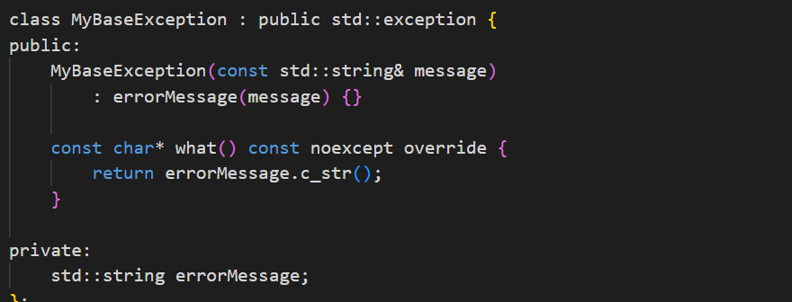

1. **Define Specific Exception Classes**:
   * Identify different categories or types of errors your program might encounter. Create specific exception classes for each category, derived from your base exception class.

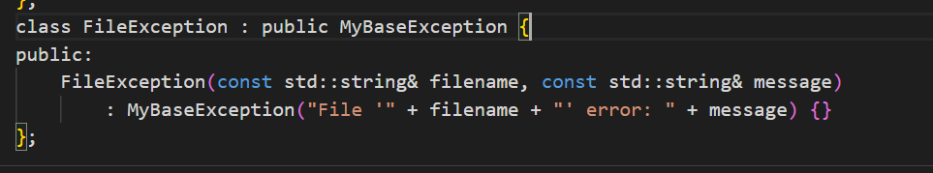

1. **Hierarchical Structure**:
   * Create a hierarchy by subclassing more specific exceptions from more general ones, if it makes sense in your application. This allows you to handle errors at different levels of abstraction.

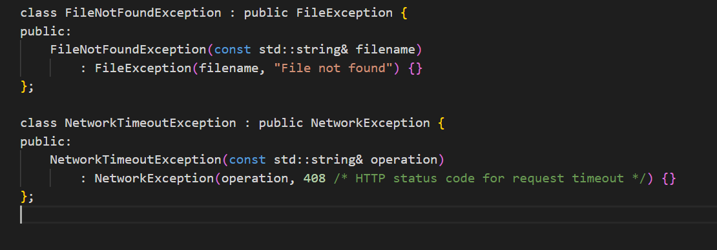

1. **Reuse and Maintainability**:
   * By organizing exceptions into a hierarchy, you can reuse common error-handling logic across related exceptions. This reduces code duplication and makes maintenance easier because changes can be applied uniformly across related exceptions.
2. **Documentation and Consistency**:
   * Document each exception class clearly, including when and why it should be thrown. Follow naming conventions and establish consistent patterns for how exceptions are defined and used throughout your codebase.
3. **Handle Exceptions Appropriately**:
   * Ensure that exception handling code catches exceptions at an appropriate level of abstraction. Use catch blocks to handle exceptions based on their specific types to provide tailored error messages or recovery mechanisms.

### **Example Usage:**

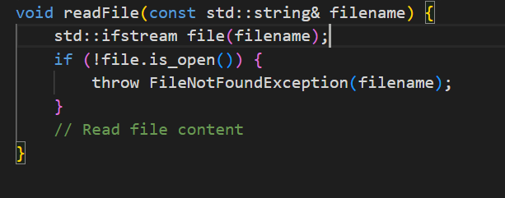

In this example, **FileNotFoundException** is thrown when a file cannot be found, providing a clear and specific error message.

By following these steps, you can design a well-structured hierarchy of exception classes that enhances the maintainability and reusability of your code, while also improving clarity and ease of debugging during error handling.

**Q.5>When might it be appropriate to not use exceptions in C++ for error handling? Explain your reasoning.**

**There are several scenarios where it might be appropriate to avoid using exceptions in C++ for error handling:**

1. Performance-Critical Applications:
   * In applications where performance is critical and every nanosecond counts, exception handling overhead might be too costly.
2. Embedded Systems or Limited Resources:
   * Embedded systems or environments with limited resources (such as microcontrollers or real-time systems) may not support or may not efficiently handle exception mechanisms..
3. Code Size Constraints:
   * Some platforms or applications have strict code size limitations. Legacy Codebases:
   * In legacy codebases that heavily rely on existing error-handling mechanisms (such as return codes or global error flags), introducing exceptions may introduce compatibility issues or require extensive refactoring..
4. Predictable Control Flow:
   * In certain algorithms or workflows where error conditions are expected and can be handled predictably without disrupting the normal control flow, using return codes or other structured error-handling mechanisms can simplify code logic and make it more straightforward to follow.
5. API Design Considerations:
   * When designing APIs that are expected to be used across different programming languages or environments, exceptions may not be universally supported or may behave differently..
6. Avoiding Unnecessary Complexity:
   * For simple applications or modules where error conditions are straightforward and exceptional cases are rare or easily recoverable, using exceptions might introduce unnecessary complexity.